|  |  |  |  |  |  |  |  |  |  |  |  |
| --- | --- | --- | --- | --- | --- | --- | --- | --- | --- | --- | --- |
|  | | **Hope Foundation’s,**  **Finolex Academy of Management and Technology, Ratnagiri** | | | | | | | | | |
| **Department of Information Technology** | | | | | | | | | |
| Subject name: OLAP LAB | | | | | | | | Subject Code: ITL503 | | | |
| Class | | TE IT | | Semester – V (CBCGS) | | | | Academic year: 2018-19 | | | |
| Name of Student | | **Kazi Jawwad A Rahim** | | | | | **QUIZ Score : 04** | | | | |
| Roll No | | **32** | | | Assignment/Experiment No. | | | | | 05 | |
| Title**:** To implement horizontal and vertical fragmentation in distributed database. | | | | | | | | | | | |
|  | | | | | | | | | | | |
| 1. **Course objectives applicable:**   **LOB1**- To understand various aspects of Distributed database concepts like creating different types of Fragmentation. | | | | | | | | | | | |
| 1. **Course outcomes applicable:**   **LO1**- Get familiar with the query processing in distributed database. | | | | | | | | | | | |
| **3. Learning Objectives:**   * Understand query processing in distributed database. * To be able to design queries to retrieve data from a distributed database. * To understand the techniques used for data fragmentation, | | | | | | | | | | | |
| 1. **Practical applications of the assignment/experiment:**  * Large Organization, banking system and all other applications which are globally distributed. | | | | | | | | | | | |
| **5. Prerequisites**: Understanding of distributed database, types of distributed database, linked servers, SQL database concepts. | | | | | | | | | | | |
| **6. Hardware Requirements**:   1. PC with 4GB RAM, 500GB HDD,   **7. Software Requirements:**  1. SQL server 2012, SQL server Management studio 2012. | | | | | | | | | | | |
|  | | | | | | | | | | | |
| **8. Quiz Questions (if any): (Online Exam will be taken separately batch wise, attach the certificate/ Marks obtained):**  <https://goo.gl/9RRUPa> | | | | | | | | | | | |
|  | | | | | | | | | | | |
| **9. Experiment/Assignment Evaluation:** | | | | | | | | | | | |
| **Sr. No.** | **Parameters** | | | | | | | | **Marks obtained** | | **Out of** |
| **1** | Technical Understanding (Assessment may be done based on Q & A **or** any other relevant method.) Teacher should mention the other method used - | | | | | | | |  | | 6 |
| **2** | Neatness/presentation | | | | | | | |  | | 2 |
| **3** | Punctuality | | | | | | | |  | | 2 |
| **Date of performance (DOP)** | | |  | | | **Total marks obtained** | | |  | | **10** |
| **Date of checking (DOC)** | | |  | | | **Signature of teacher** | | | | | |

**Results:**

**1. Horizontal Fragmentation:-**

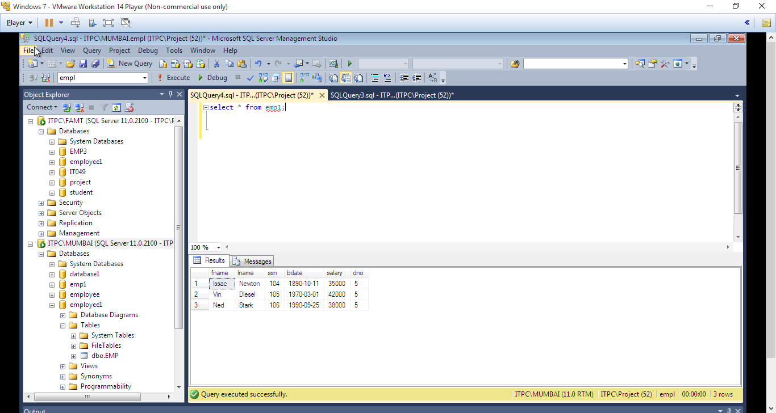

**Figure 1**: **Above is the result from Employee table on S1.**

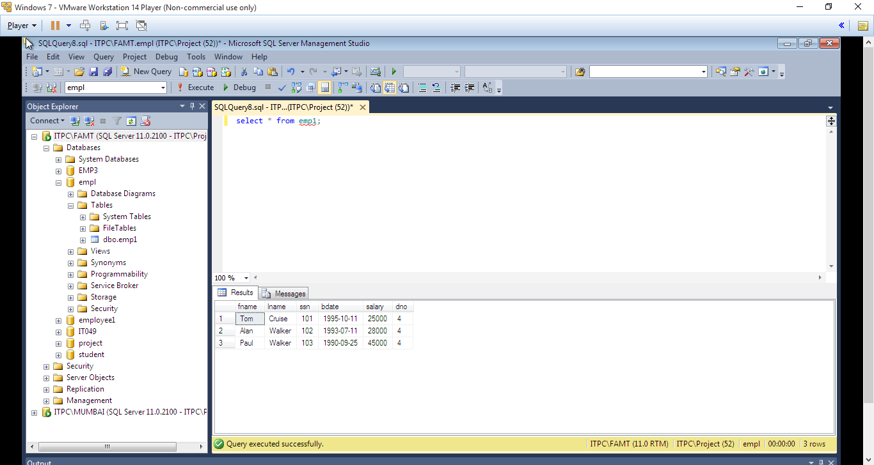

**Figure 2**: **Above is the result from Employee table on S2.**

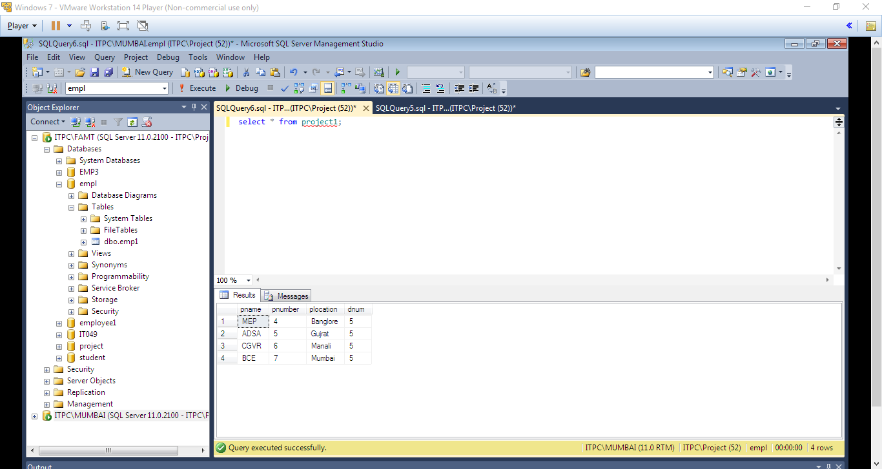

**Figure 3**: **Above is the result from Project table on S1.**

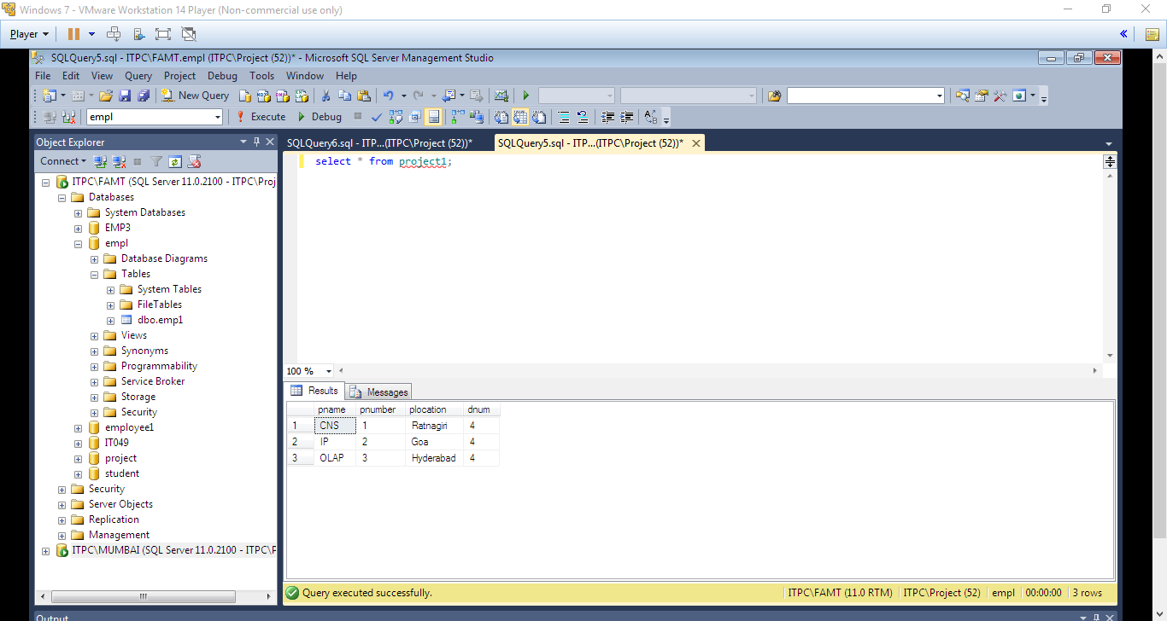

**Figure 3**: **Above is the result from Project table on S2.**

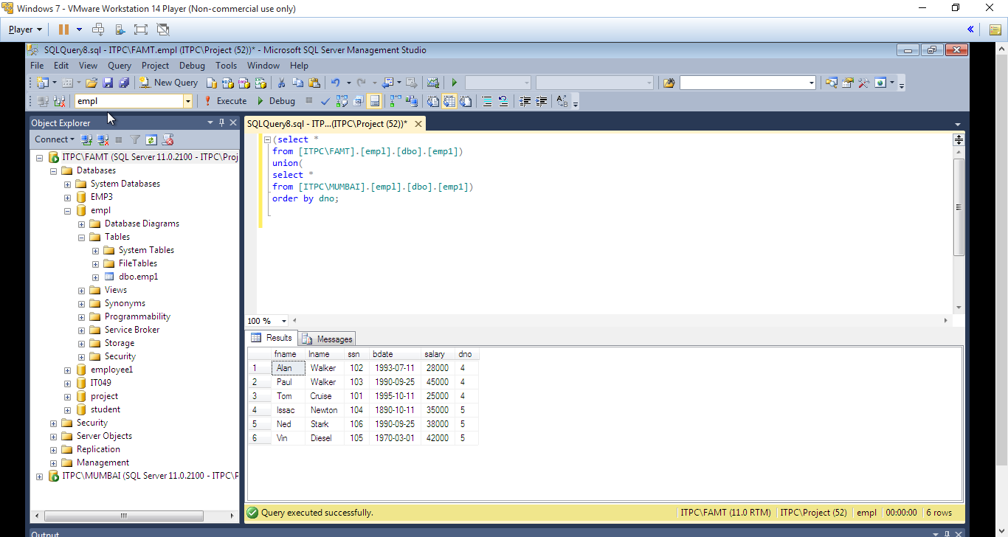

**Figure 4: Reconstruction of Employee table**

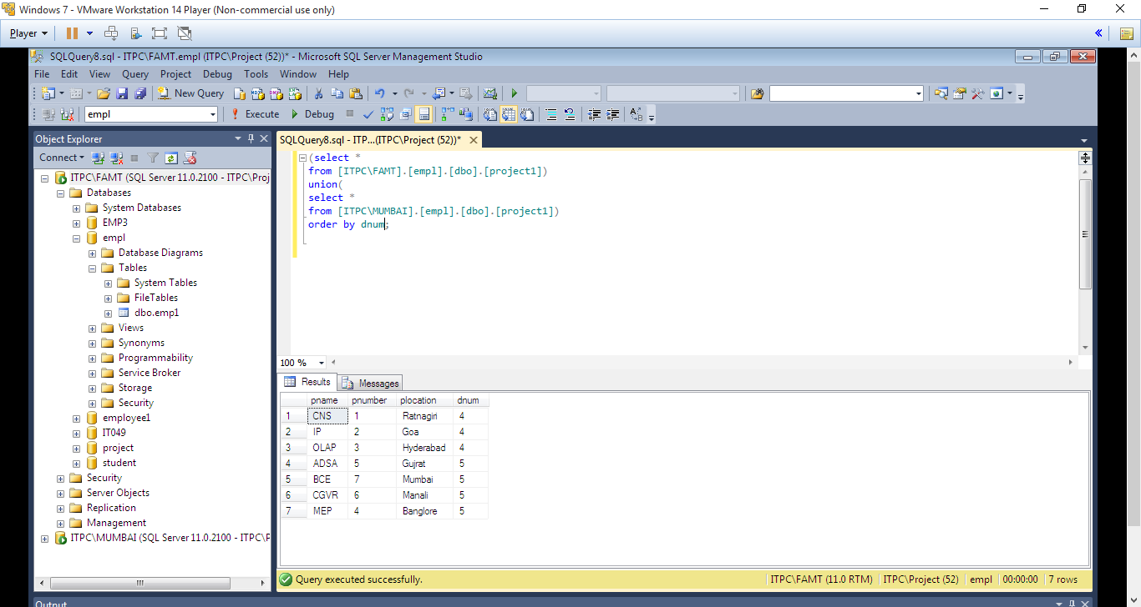

**Figure 5: Reconstruction of Project table**

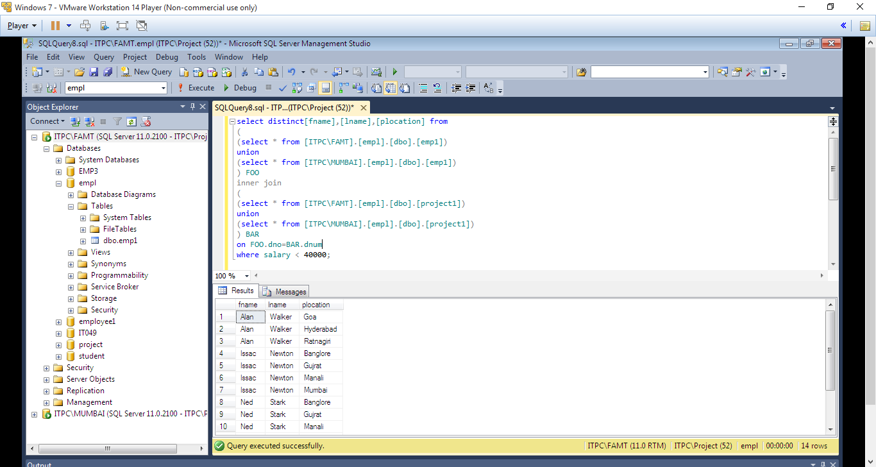

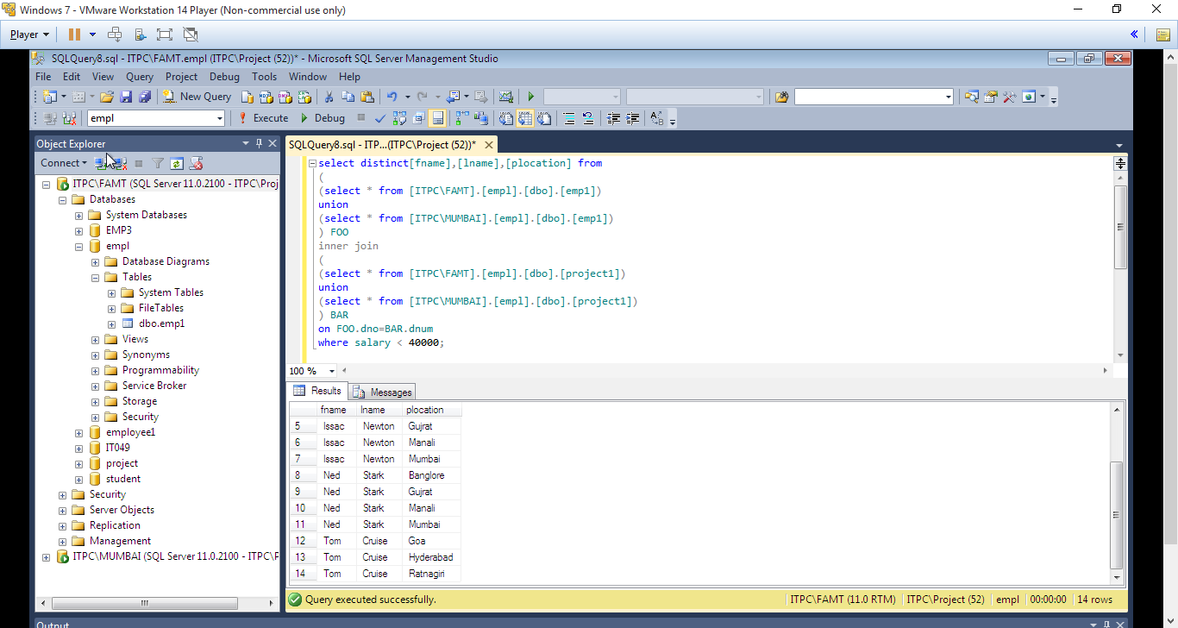

**Figure 6:- Display the names of employee and their project location with salary < 40000**

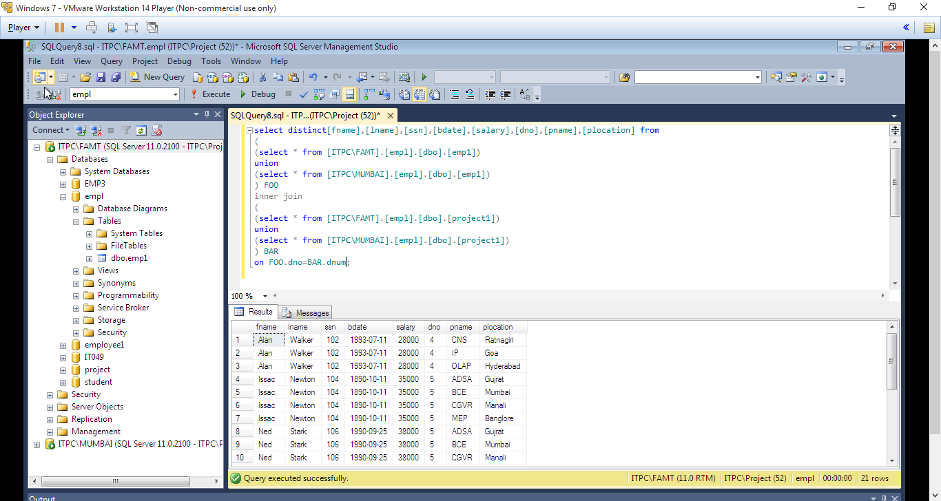

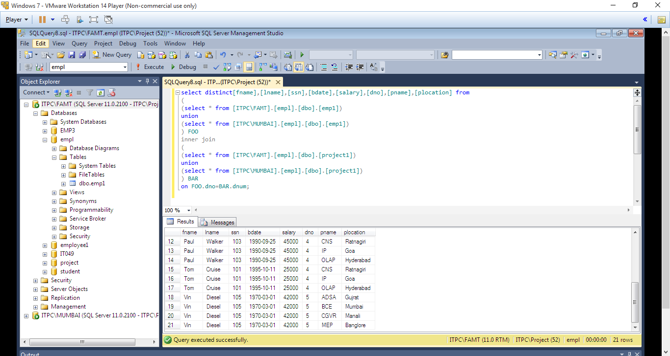

**Figure 7: Display the employee details with Dno is 4 and 5**

**2. Vertical Fragmentation**

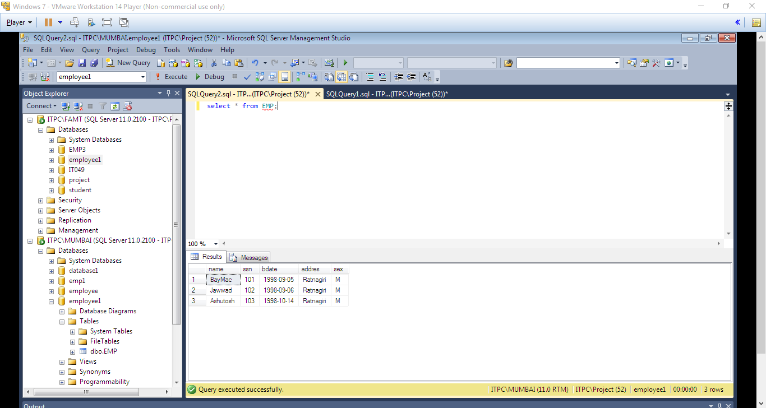

**Figure 8:- Above is the result Employee S1**

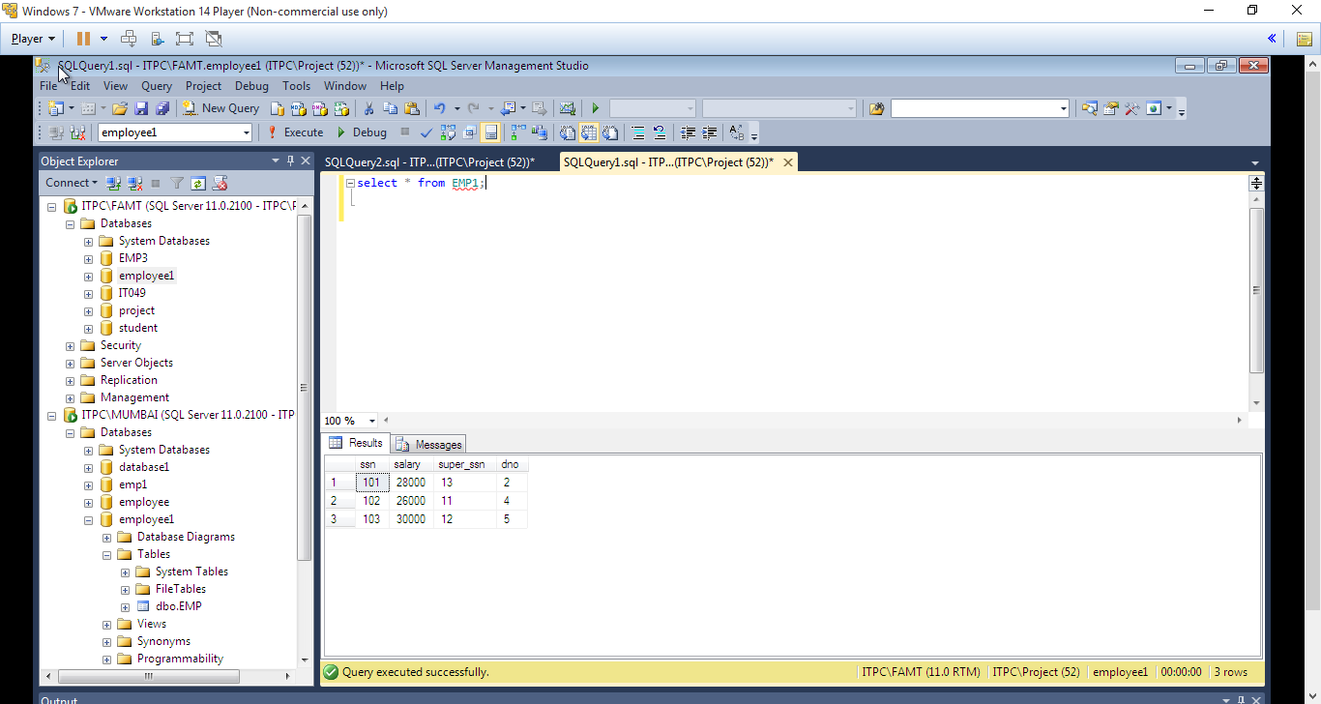

**Figure 9:- Above is the result Employee S2**

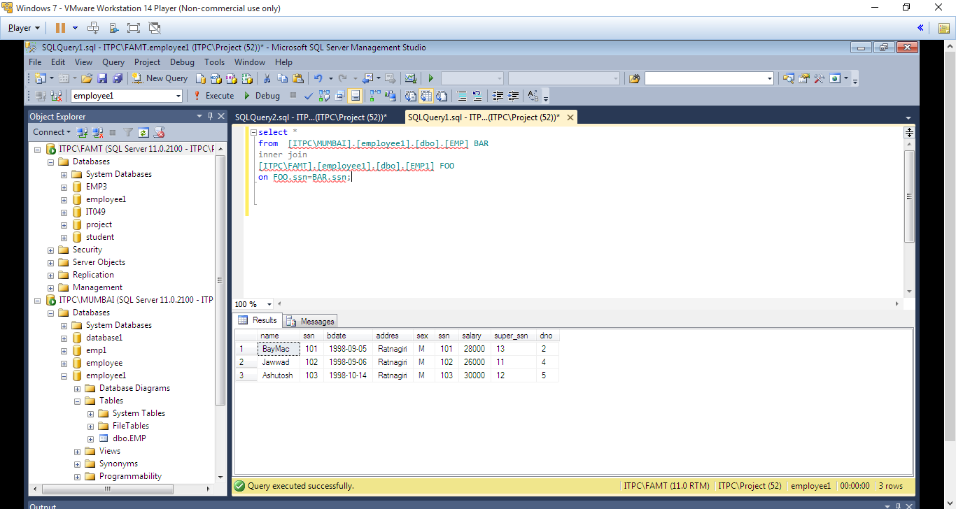

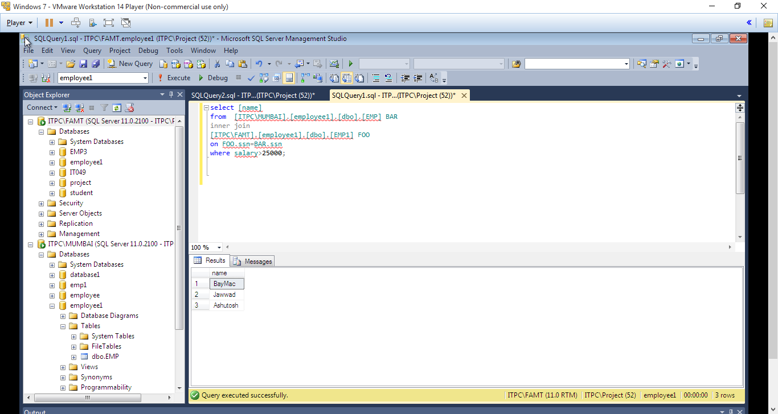

**Figure 10:- Display the employee names with salary greater than 25000**

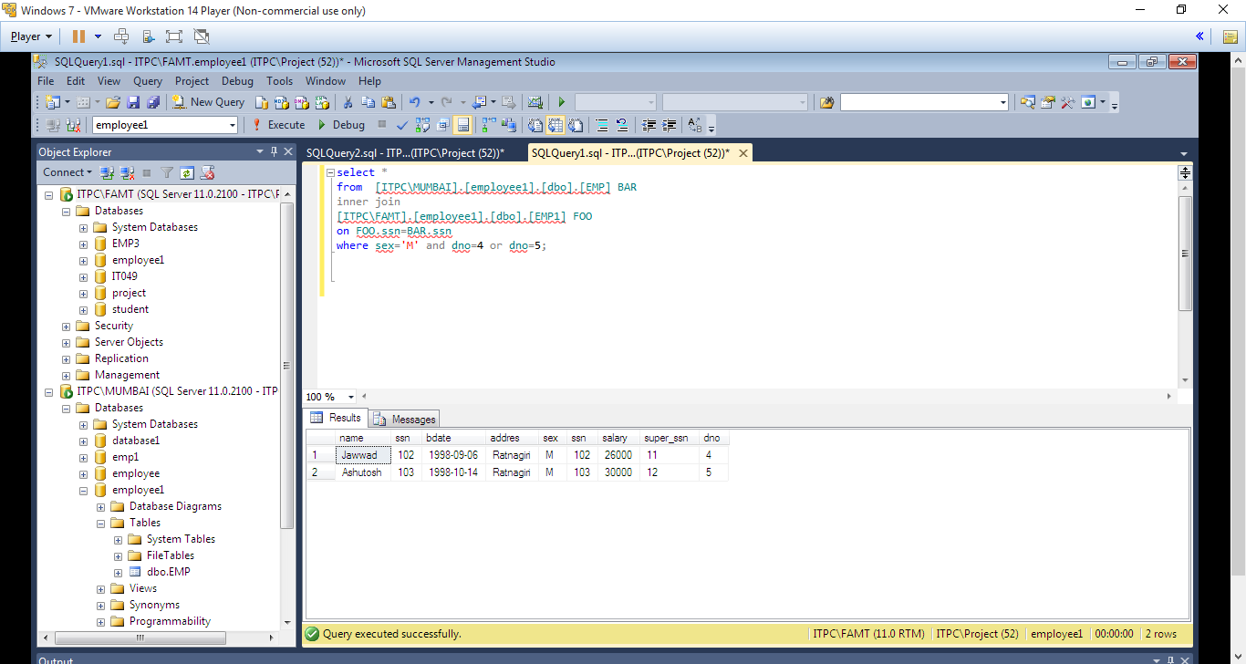

**Figure 11:- Display the information of male employee working in department 4 and 5.**

**References**:

1. Distributed Databases - Principles and Systems; Stefano Ceri; Guiseppe Pelagatti; Tata McGraw Hill; 1985

**2.** Principles of Distributed Database Systems; M. Tamer Özsu; and Patrick Valduriez Prentice Hall

3. https://docs.microsoft.com/en-us/sql/relational-databases/linked-servers/create-linked-servers-sql-server-database-engine?view=sql-server-2017